Stock Projections to Rebuild WCNPO Striped Marlin
under WCPFC CMM 24-06

Jon Brodziak*
* Pacific Islands Fisheries Science Center
National Marine Fisheries Service
1845 Wasp Boulevard
Honolulu, HI 96818 USA
Email: Jon.Brodziak@NOAA.GOV

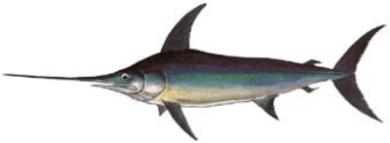
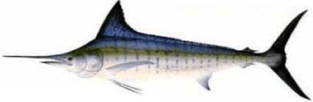

At the 21st Commission meeting in 2024, the Western and Central Pacific Fisheries Commission adopted Conservation and Management Measure (CMM) 24-06 for Western and Central North Pacific Ocean (WCNPO) Striped Marlin. CMM 24-06 replaced CMM 2010-01 with an total catch limit of 2400 mt by WCPFC countries during 2025-2027 along with provisions for carryover catches if observed catches were under the catch limit. Under CMM 24-06, Commission Members, Cooperating Non-Members, and Participating Territories (CCMs) agreed to ensure that the total catch will not exceed 2400 mt of catch for each year between 2025 – 2027. This is based on a 60% reduction from the highest catch between 2000 and 2003. If CCMs cumulatively catch in excess of 2400 mt in any given year, the measure will be reviewed the following year. The CMM 24-06 is planned to be reviewed and amended as needed in 2027, pending the completion of a new stock assessment conducted by ISC.
This working paper describes three rebuilding projections under CMM 2024-06 for Western and Central North Pacific Ocean (WCNPO) striped marlin. Under CMM 2024-06 if the annual catch limit of 2,400 metric tons of WCNPO striped marlin (MLS) is not fully utilized countries may carry over up to 165 metric tons of their individual quota to the following year. Specifically, an underage of 826 mt in 2023 allows for a carryover increase of up to 165 metric tons in 2025. Similarly, potential underages in 2024 and 2025 can be applied to 2026 and 2027, respectively. However, no CCM may exceed a 165 metric ton increase in any carryover year, and any overage will be deducted from that country's individual limit in the subsequent year.
At the January 2025 ISC Billfish Working Group Meeting, the WG agreed to produce additional projections to measure the probable impacts of including carryover catch in MLS rebuilding analyses for 2025-2027. This working paper describes rebuilding projections to address three scenarios for potential underages and carryover of MLS catches in 2025-2027. The first scenario represents a constant annual catch with no carryover (Table 1) and sets total catch at 2400 mt during 2025-2027. Catches in 2028-2031 and 2032-2034 were set at 2300 mt and 2200 mt, respectively, to illustrate reaching at least a 60% probability of achieving the MLS rebuilding target in 2034. The second scenario sets catch at 3225 mt in 2025 and 2400 mt during 2026-2027. This scenario represents a catch measure with carryover in 2025 (Table 1). Catches in 2028-2031 and 2032-2034 were set at 2200 mt to illustrate reaching at least a 60% probability of meeting the MLS rebuilding target in 2034. The third scenario sets catch at 3225 mt in 2025-2026 and 2400 mt during 2027. This scenario represents a catch measure with carryover in 2025-2026 (Table 1). Catches in 2028-2031 and 2032-2034 were set at 2150 mt to illustrate reaching at least a 60% probability of achieving the MLS rebuilding target in 2034. Overall, the three scenarios show the probable rebuilding outcomes for alternative carryover catches under CMM 24-06.
We updated the 2024 rebuilding analyses for WCNPO Striped Marlin to run the CMM 24-06 projections using the most up-to-date information. This required some changes to the input data for the 2024 rebuilding analysis models (Brodziak 2024). In particular, the input catch data used for the CMM 24-06 scenarios differed from those used in the 2024 rebuilding analyses in two ways. First, we gathered new input MLS catch data for 2021-2024 to calculate spawning biomasses and fishing mortalities during 2021-2024. Here using the best scientific information on catch data for the CMM 24-06 scenarios replaced the assumption that recent average fishing mortality from 2018-2020 was used to project the MLS harvest in 2021-2024 (Brodziak 2024). Second, as agreed at the January 2025 meeting, we applied the average proportion of catch by country and assessment fleet group in 2020 to apportion catch by country to fleet groups for 2025-2027. This apportionment was used for the only two countries, Japan and Taiwan, which both had some MLS catches in two or more assessment fleet groups. Overall, the CMM 24-06 scenarios used 2021-2024 catch data to initialize the projection runs and determined catches during 2028-2034 to rebuild MLS with at least a 60% probability in 2034.
We set the input MLS catch data in 2021-2024 based on the 2024 WCPFC Tuna Fishery Yearbook (WCPFC 2024, https://www.wcpfc.int/doc/wcpfc-tuna-fishery-yearbook-2024) for all CCMs in the WCPFC, except Japan and USA. The WCPFC Yearbook catch data provides MLS catches in the WCPFC Area north of the equator during 2021-2023. The 2024 MLS catches were not yet reported to the WCPFC and were imputed from the 2023 catch values reported by each country.
Japanese catch data for 2021-2024 were based on reported catches by each Japanese fleet defined in the most recent MLS stock assessment (ISC Billfish WG 2023). Reported catches by fleet were based on catch data gathered from the most recent 2025 database sources (M. Jusup, personal communication, February 26, 2025).
USA catch data for 2021-2024 are based on reported catches for the Hawaii longline fleet and for the Hawaii recreational fleet. Reported catches by fleet are based on catch data gathered from the most recent 2025 database sources.

Catch data for 2021-2024 are allocated to the nine fleet groups used in the MLS assessment. Catches by each country are uniquely assigned to a single fleet group for all countries, except Japan and Taiwan. Japanese catches by fleet in 2021-2024 are assigned to fleet group based on the observed proportion of Japanese catch by fleet group in 2020. Taiwanese catches by fleet in 2021-2024 are assigned to fleet group based on the observed proportion of Japanese catch by fleet group in 2020.

Projected catch data by country for 2025-2027 are allocated to the nine fleet groups used in the MLS assessment. The catch allocations by country under each scenario are based on assumed CMM 24-06 values.

The three catch scenarios use the same observed catches and fleet group allocations in 2021-2024. The three scenarios assume different projected catches by country during 2025-2027. The first scenario sets total catch by all countries at 2400 mt during 2025-2027. The second scenario increases total catch in 2025 to XXX mt with 2400 mt in 2026-2027. The third scenario increases total catch in 2025-2026 to XXX mt with XXX mt in 2027. The scenarios show how projected rebuilding outcomes would change under different catches in the 2025-2027, or first phase of the projection time horizon.

Catches during the second (2028-2031) and third (2032-2034) phases of the projection time horizon are set to ensure that the rebuilding probability of 60% is achieved in 2034. Catches in phases 2 and 3 under scenarios 2 and 3 are minimally adjusted from the status quo catch amount of 2400 mt to achieve the rebuilding target.

Projections under each scenario use the same set up as those developed by the ISC Billfish Working Group for a 3-phase rebuilding plan in 2024, with the exception of harvests during 2021-2024. In the 2024 projections, the status quo, or recent average fishing mortality by fleet group during 2018-2020 was used to determine projected catches during 2021-2024. This assumption of constant fishing mortality led to median total catches of about 2910, 3380, 3320, and 3030 mt in 2021-2024 (Brodziak 2024, Table 10.9, scenario 1-6). In comparison under the CMM 24-06 projections, reported catches for 2021-2023 and imputed catches for 2024 were based on the 2024 WCPFC Yearbook for all countries, except Japan and USA. Catches for Japan and USA for 2021-2024 were taken from observed values gathered from the most recent 2025 database sources. The observed catches used for the CMM 24-06 projections in 2021-2024 were 1540, 1470, 1685, and 2157 mt. The observed catches in 2021-2024 were 47%, 56%, 49%, and 29% below the predicted catches based on assuming status quo fishing mortality in the 2024 projections.

References
Brodziak J. 2024. Rebuilding Scenarios for Striped Marlin in the Western and Central North Pacific Ocean. International Scientific Committee for Tuna and Tuna-Like Species in the North Pacific/Billfish WG, ISC/24/BILLWG-01/03, 151 p. Available at: https://isc.fra.go.jp/pdf/BILL/ISC24_BILL_1/ISC_24_BILLWG-01_03.pdf
ISC Billfish WG. 2023. Annex 9: Report of the Billfish Working Group Workshop, 12-18 July 2022. Kona, Hawaii, USA. ISC/22/Annex9, 24 p. Available at: https://isc.fra.go.jp/pdf/ISC22/ISC22_ANNEX09_Report_of_the_BILLWG_Workshop_Apr2022.pdf

Table 1. Three scenarios for WCNPO striped marlin carryover catch under CMM 24-06.

Table 2. Fishing fleets, fleet groups with equal fishery selectivity used in the base case model of the 2023 stock assessment and the 2025 CMM 24-06 rebuilding analyses including fleet name and time-period where the representative fleet for each of the 9 fleet groups is shown in bold.

Table 3. WCNPO striped marlin catch biomass by assessment fleet group and fleet in 2020.

Table 4. Total and proportion of WCNPO striped marlin catch biomass in 2020 by assessment fleet group along with Japanese total and proportion of WCNPO striped marlin catch biomass by fleet group.

Table 5. Japanese catch biomass (mt) of WCNPO striped marlin by fleet group, 2021-2024.

Table 6. U.S. catch biomass (mt) of WCNPO striped marlin, 2021-2024.

Table 7. BSIA for WCNPO striped marlin catch biomass (mt) used for 2025 CMM 24-06 projections.

Figure. Fleet group 1

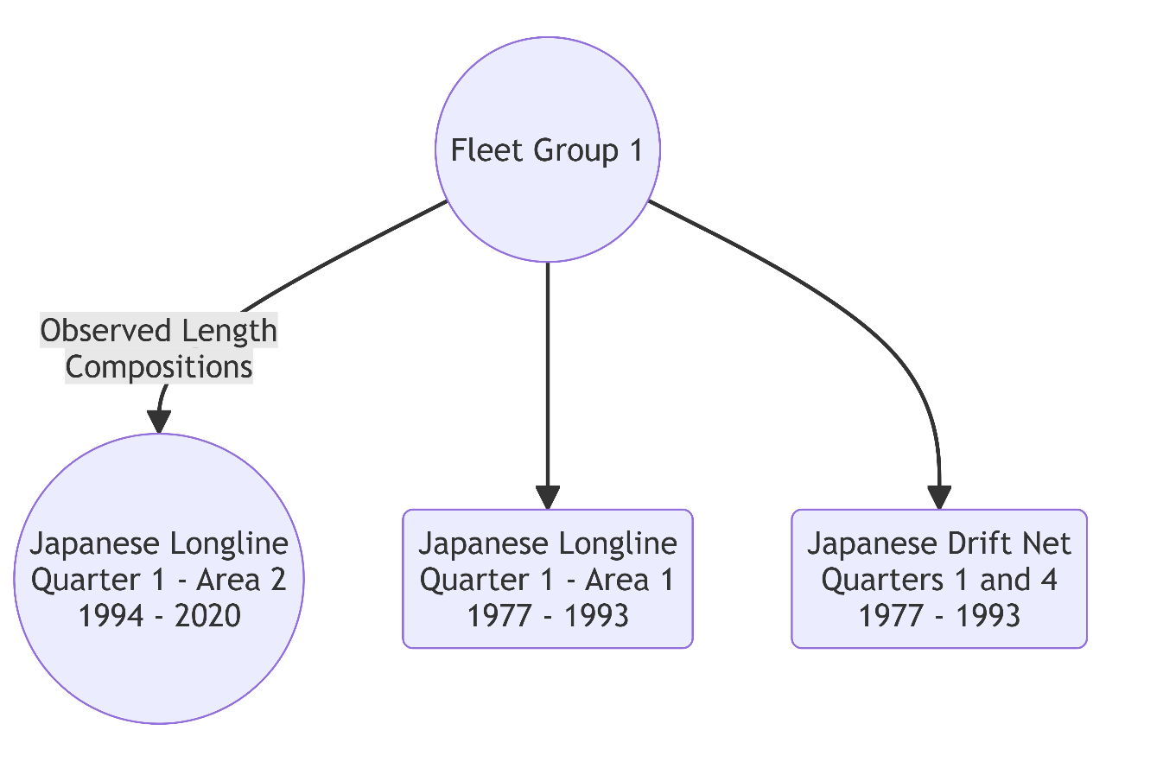

Figure. Fleet group 2

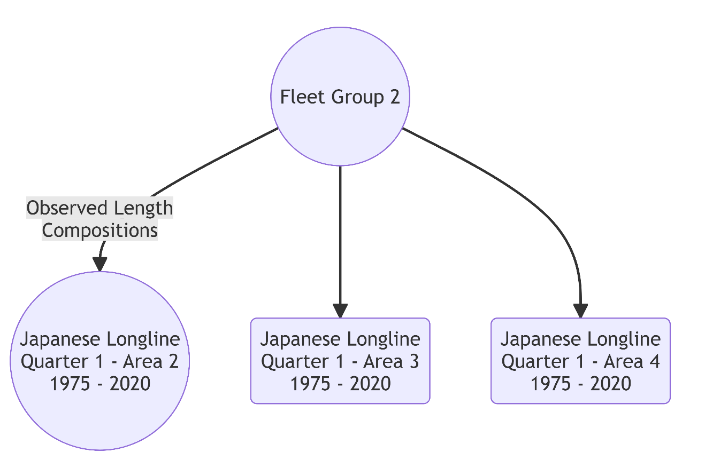

Figure. Fleet group 3

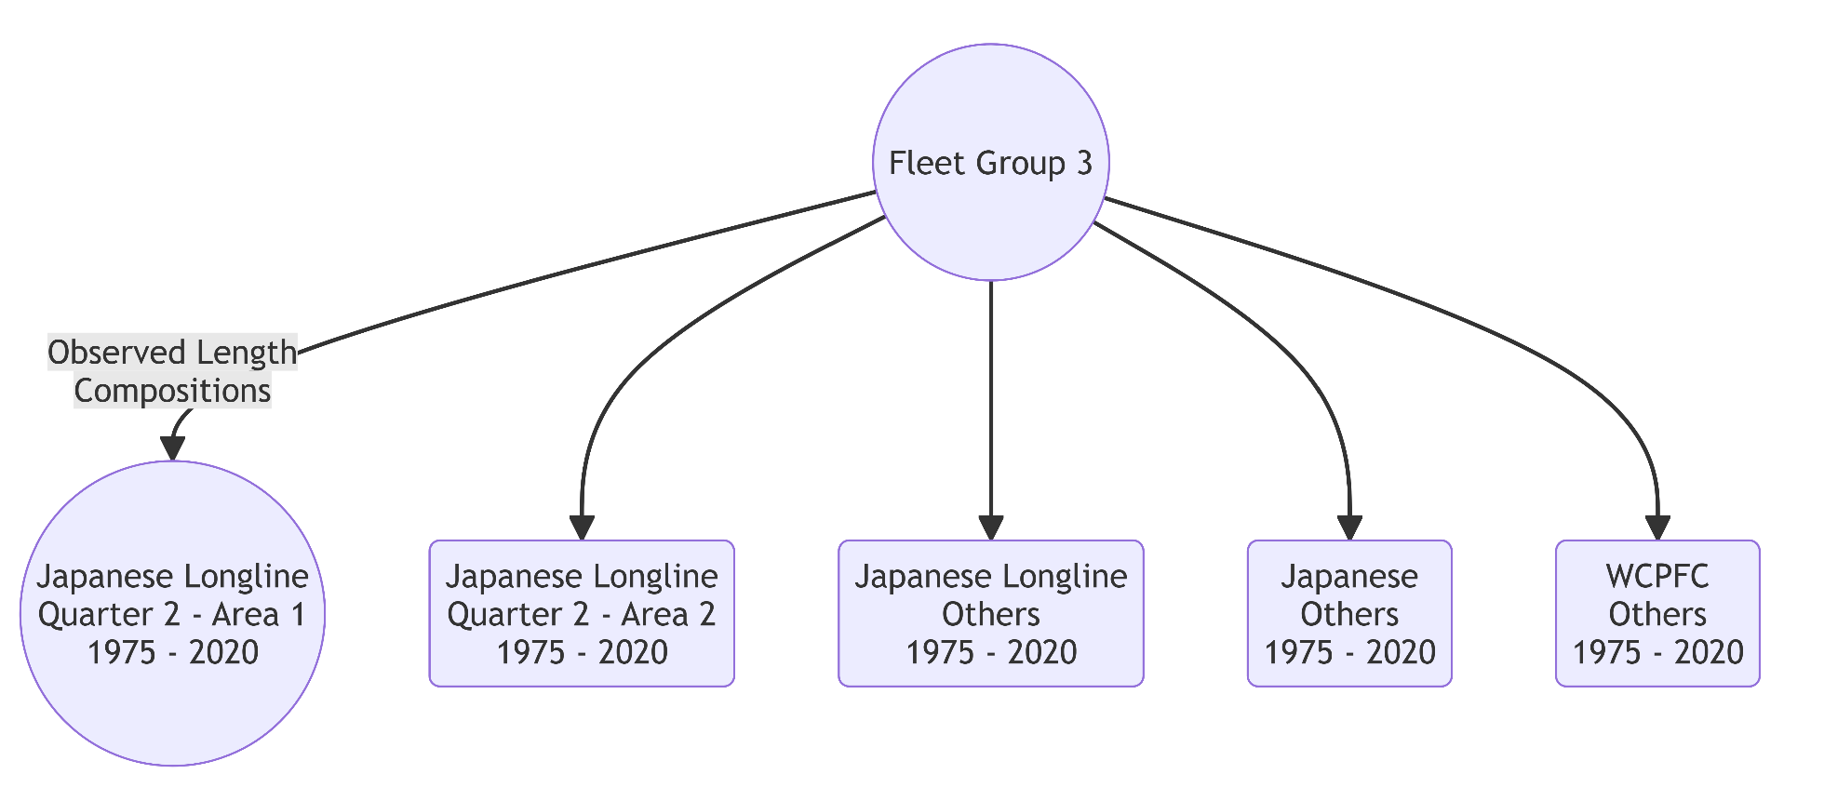

Figure. Fleet group 4

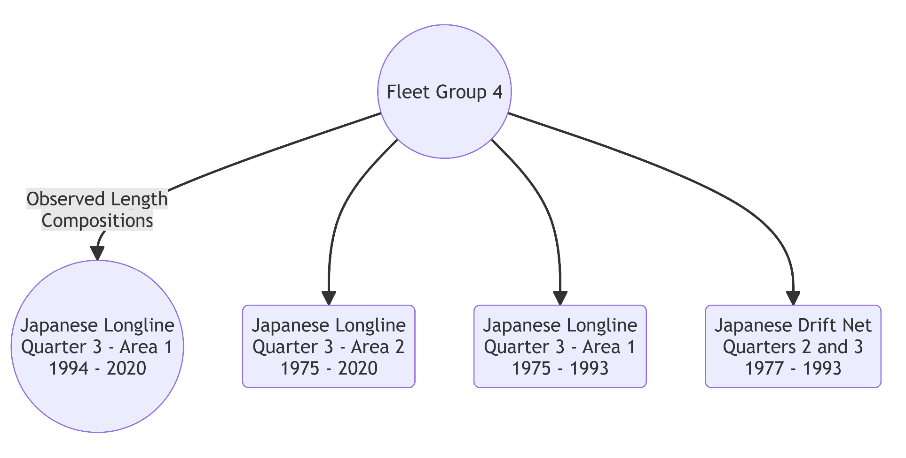

Figure. Fleet group 5

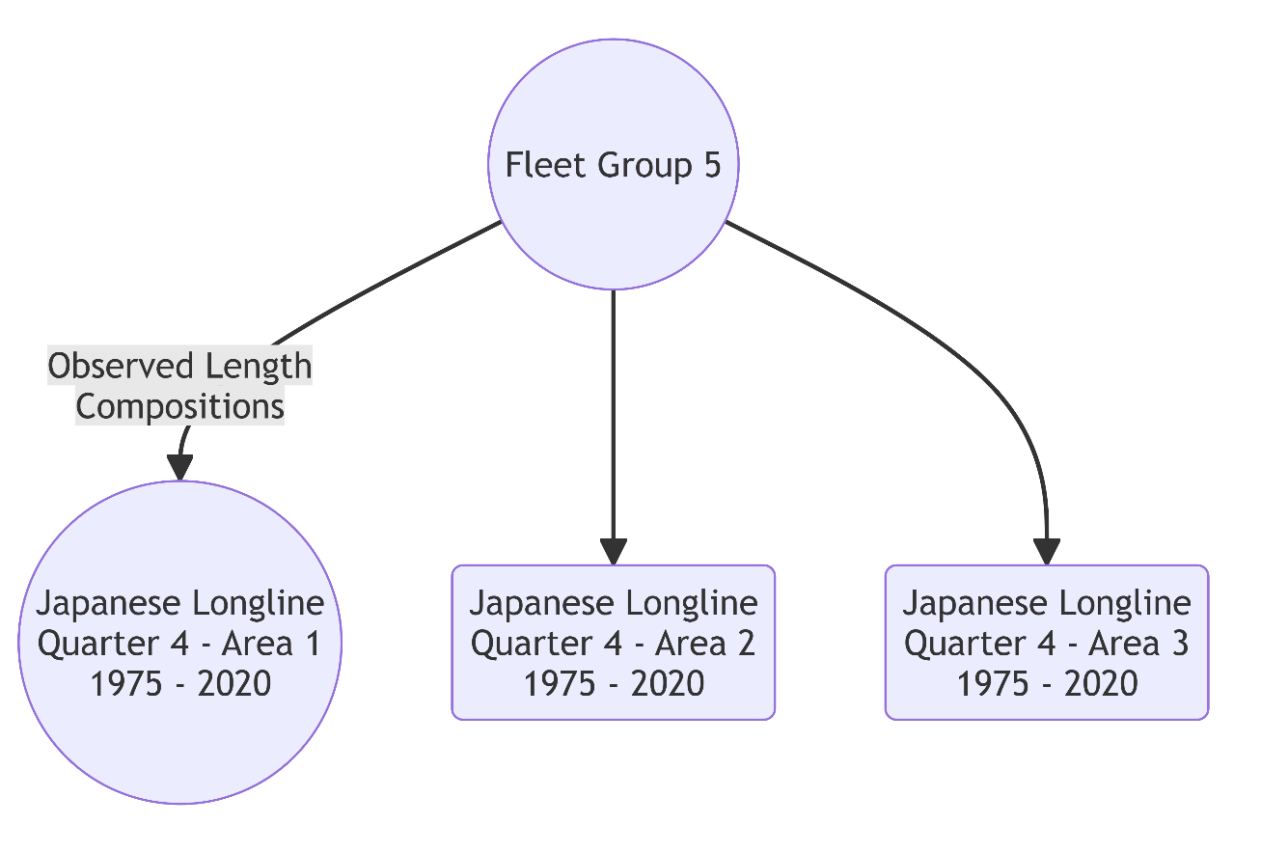

Figure. Fleet group 6

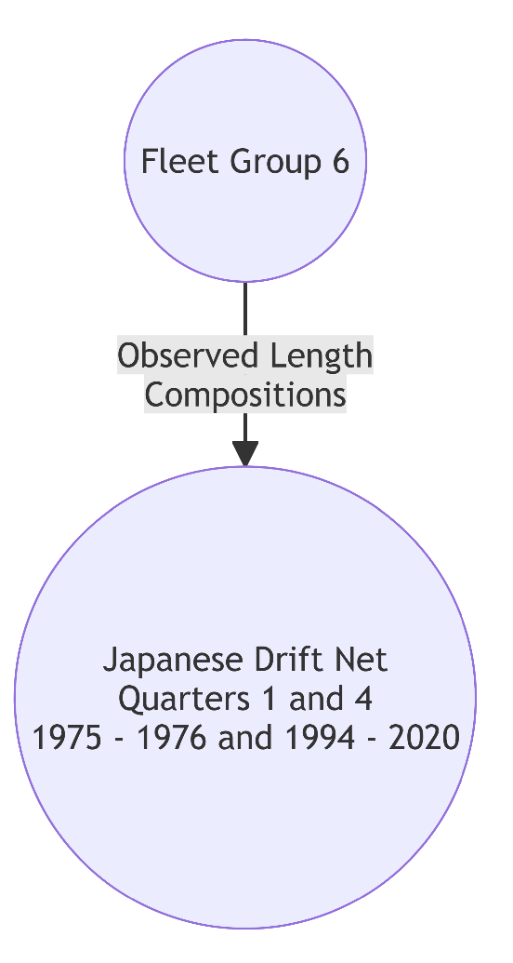

Figure. Fleet group 7

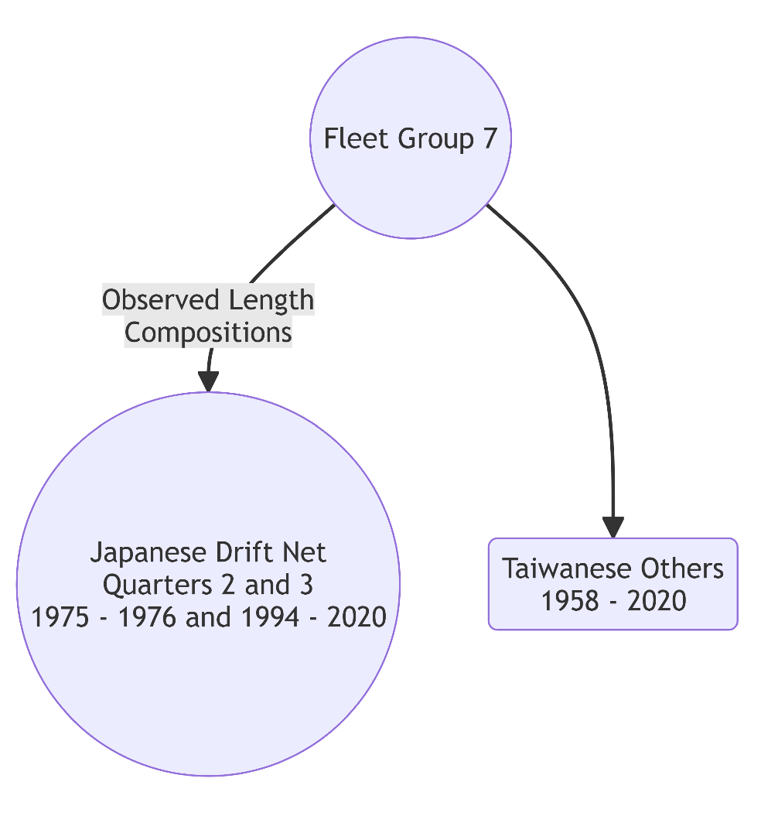

Figure. Fleet group 8

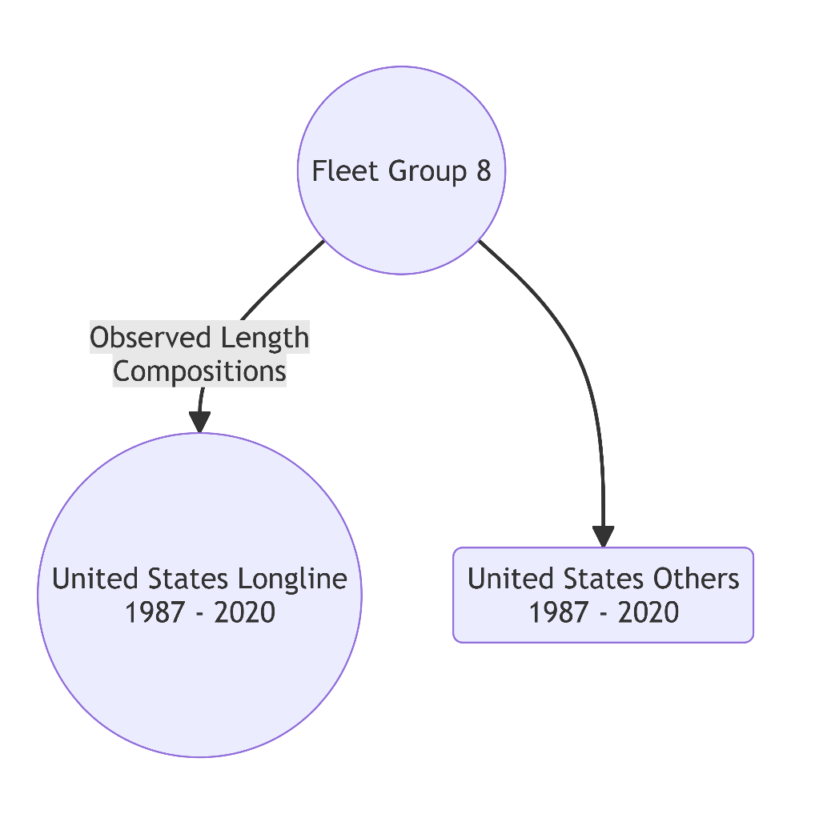

Figure. Fleet group 9

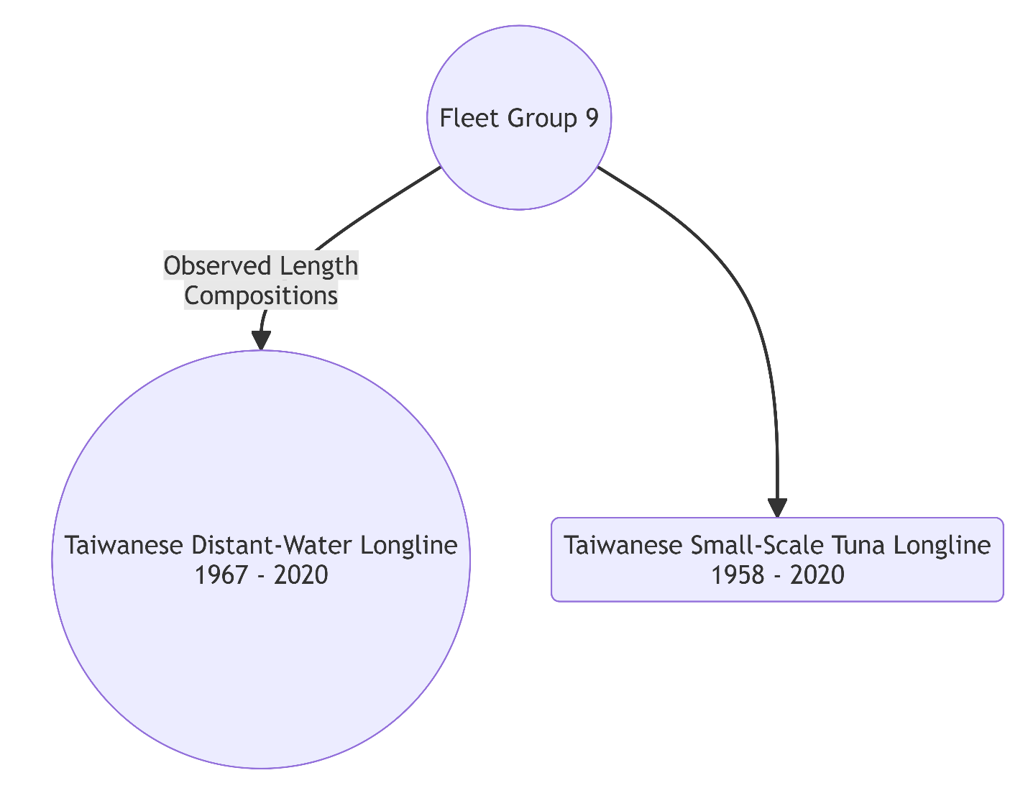

Figure.

Figure.

Figure
Figure. Japanese proportion in 2020.

Figure. Taiwanese proportion in 2020.

Figure. Japanese catch reported by ISC Billfish Working Group in 2025 by fleet group.

Figure. Comparison of Japanese catch biomass (mt) reported by ISC Billfish Working Group in 2025 and reported in WCPFC Tuna Fishery Yearbook.

Figure. U.S. catch reported by ISC Billfish Working Group in 2025 by fleet group.

Figure. Comparison of U.S. catch biomass (mt) reported by ISC Billfish Working Group in 2025 and reported in WCPFC Tuna Fishery Yearbook.

Figure.
Figure.

Figure.

Figure.

Figure.

Figure.

Figure.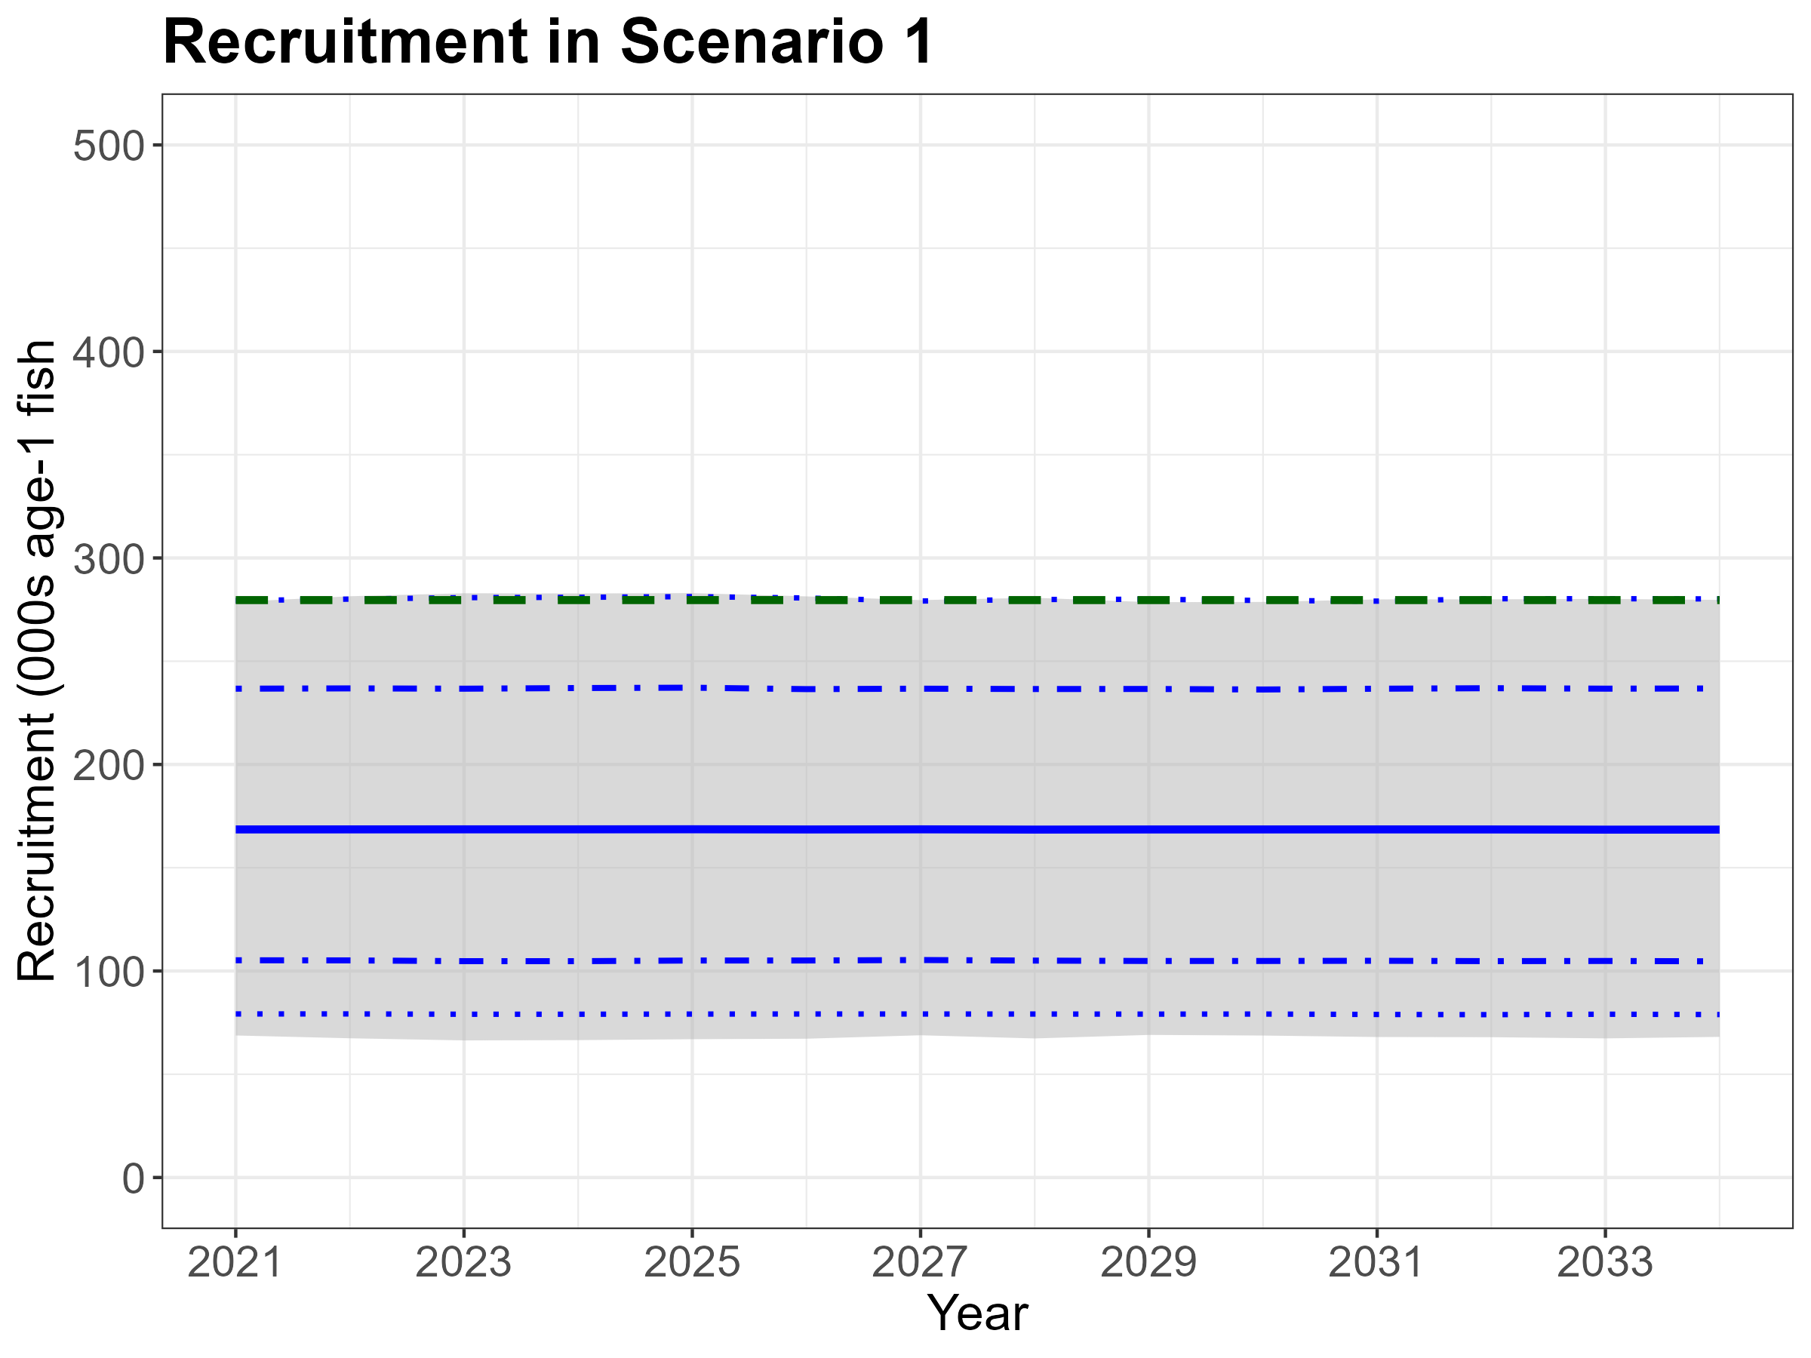
Figure.

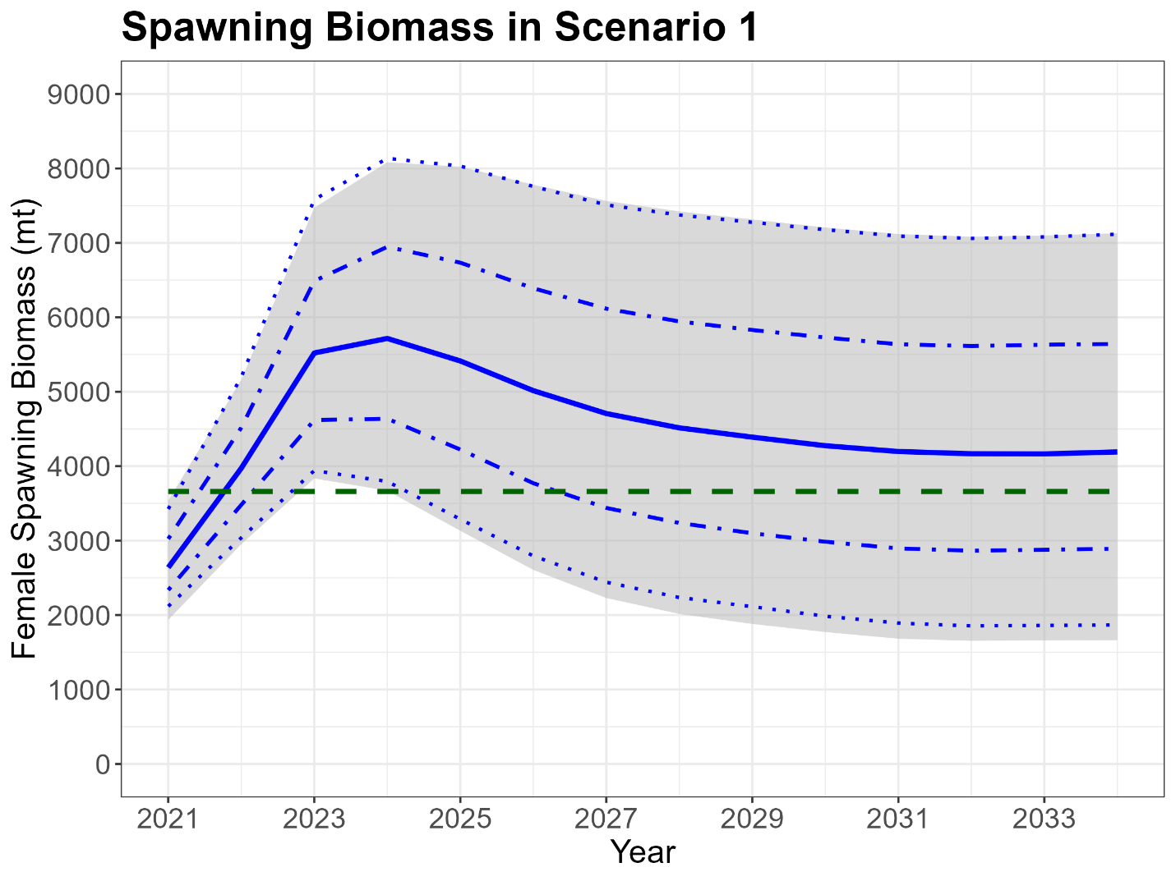

Figure.

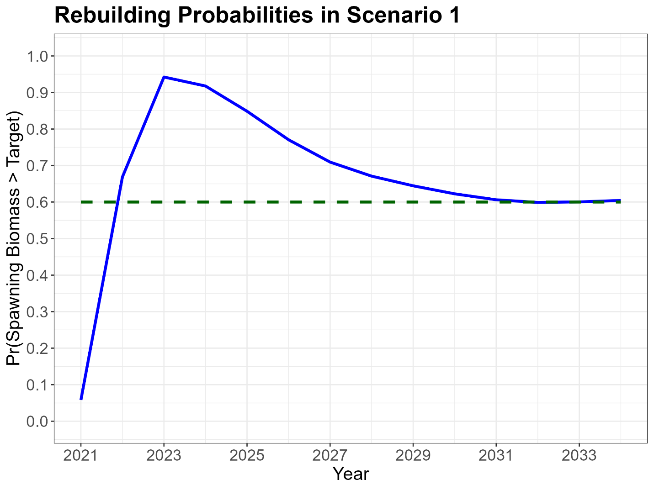

Figure.

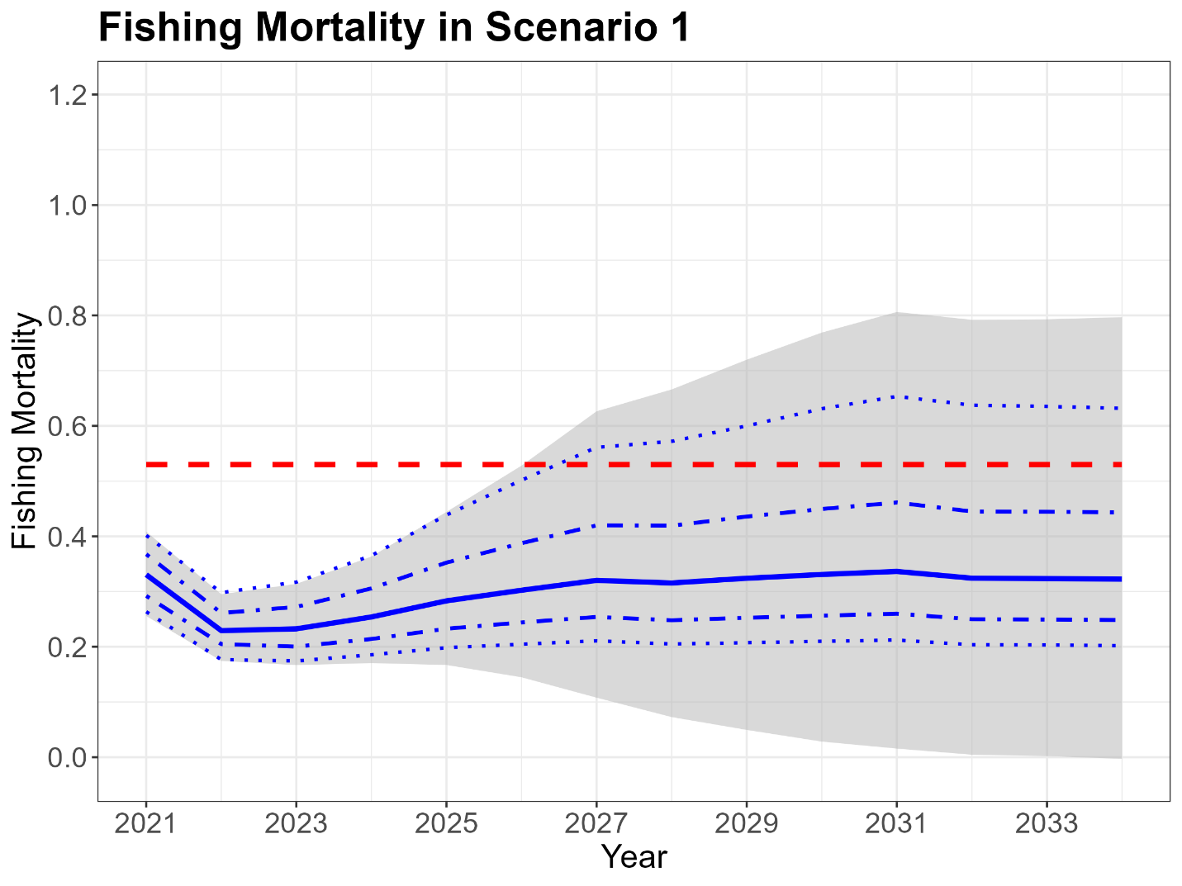

Figure.

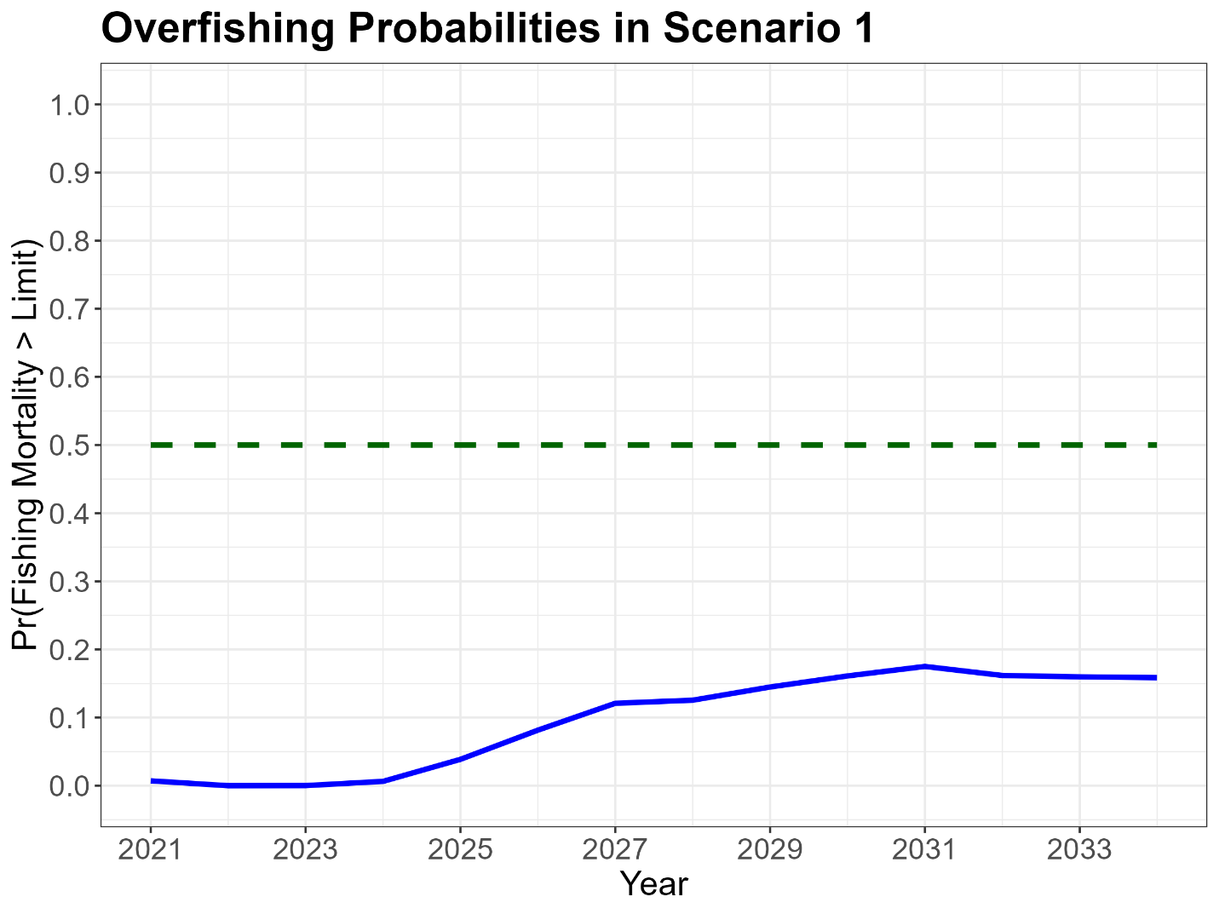

Figure.

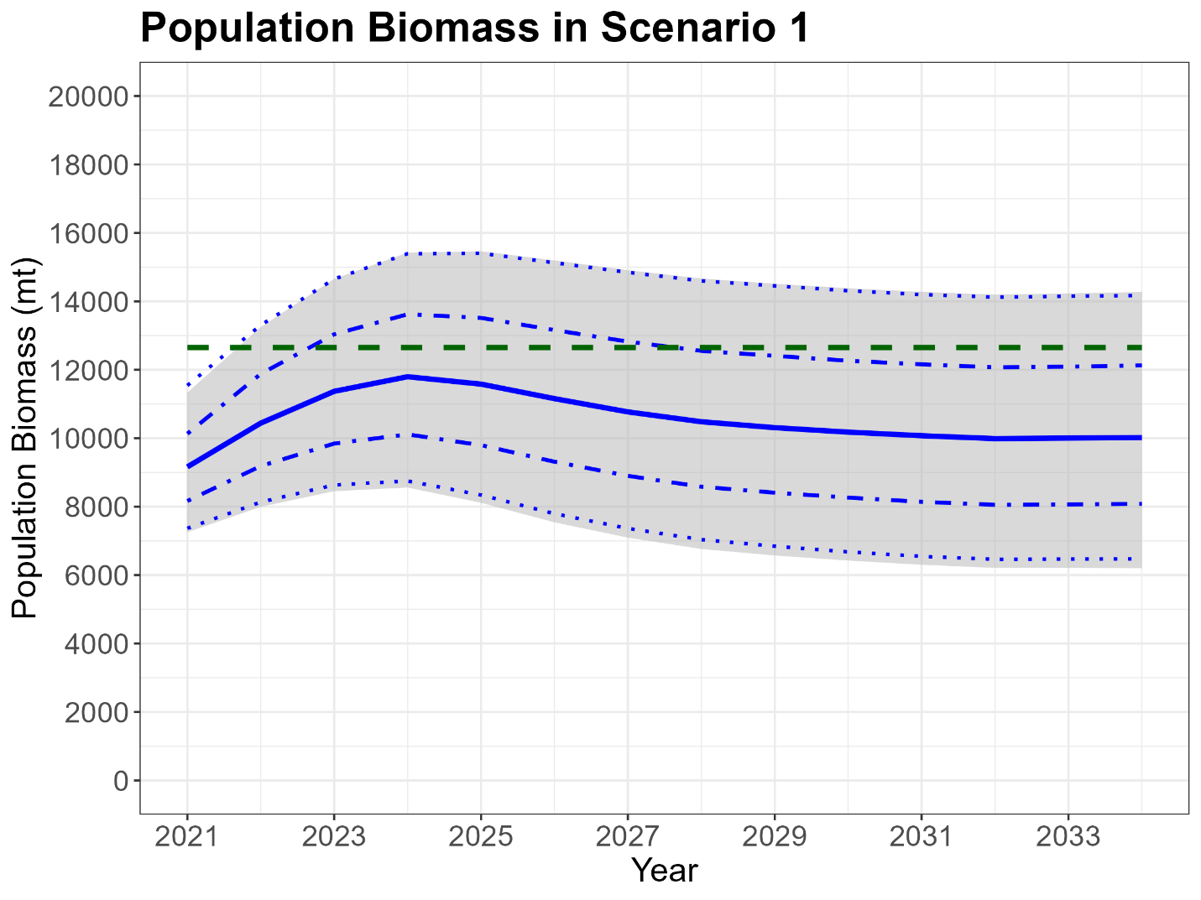

Figure.

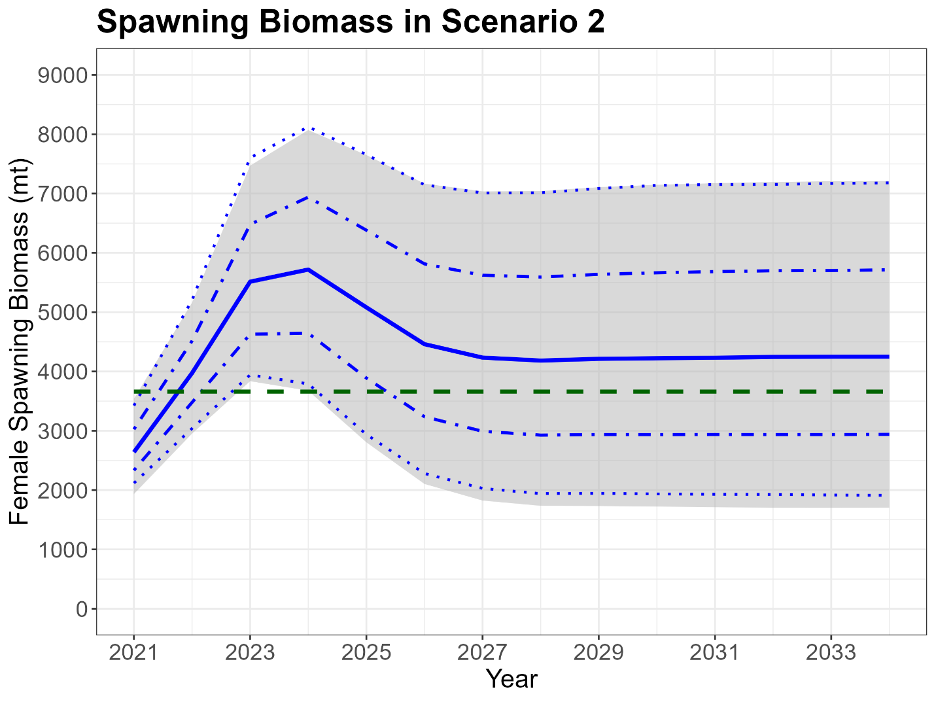

Figure.

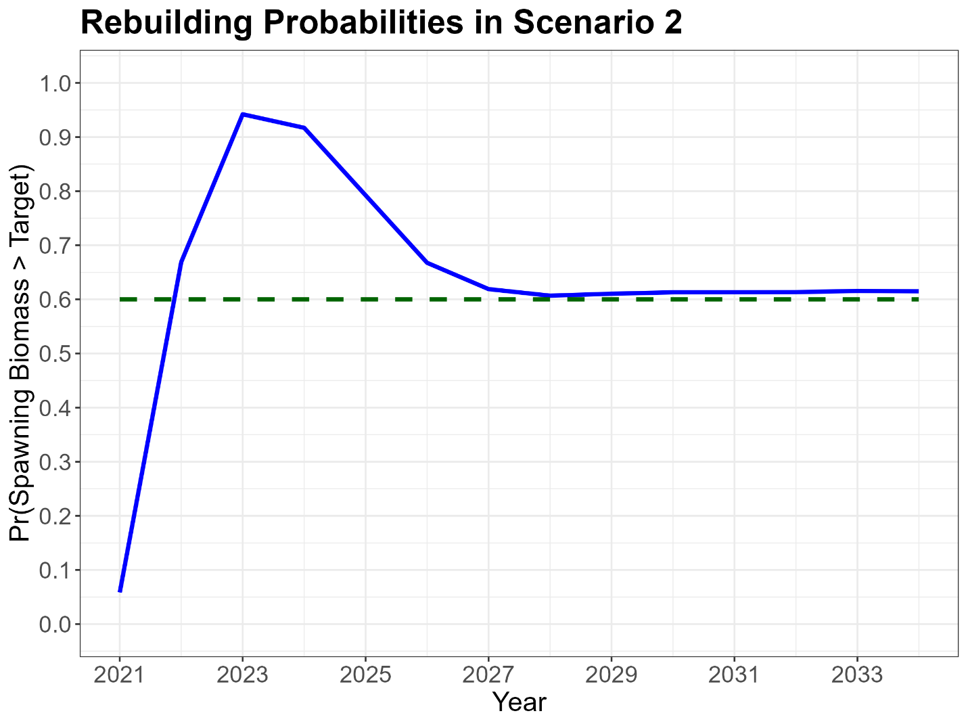

Figure.

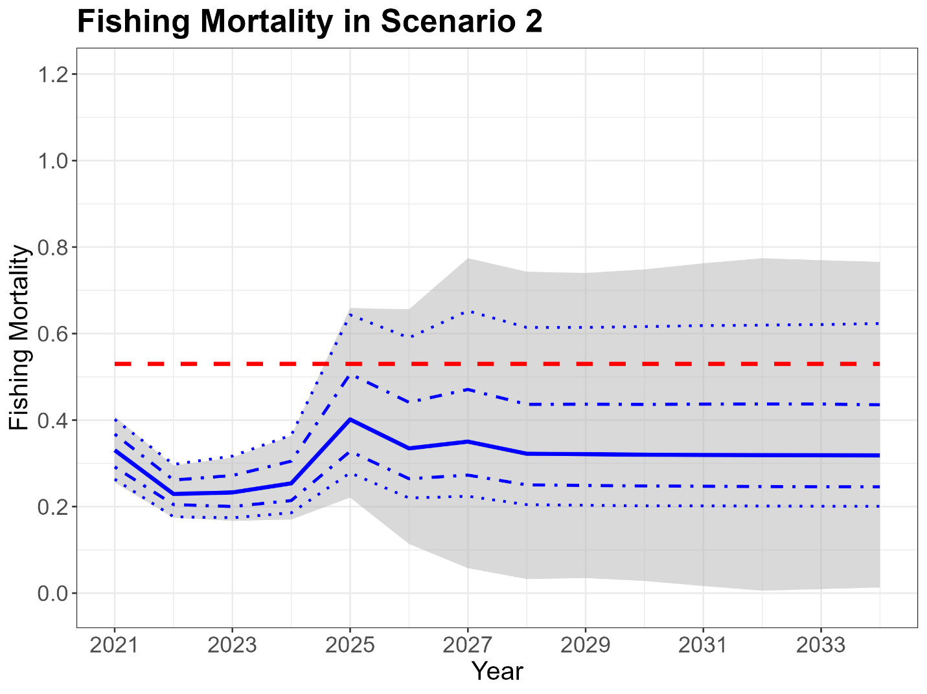

Figure.

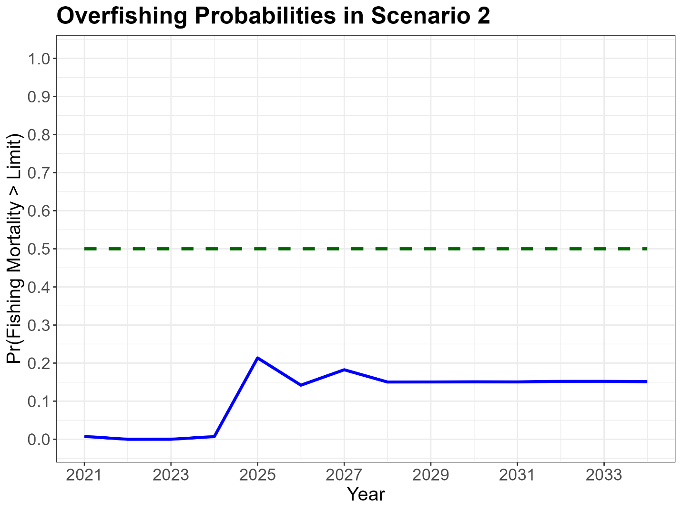

Figure.

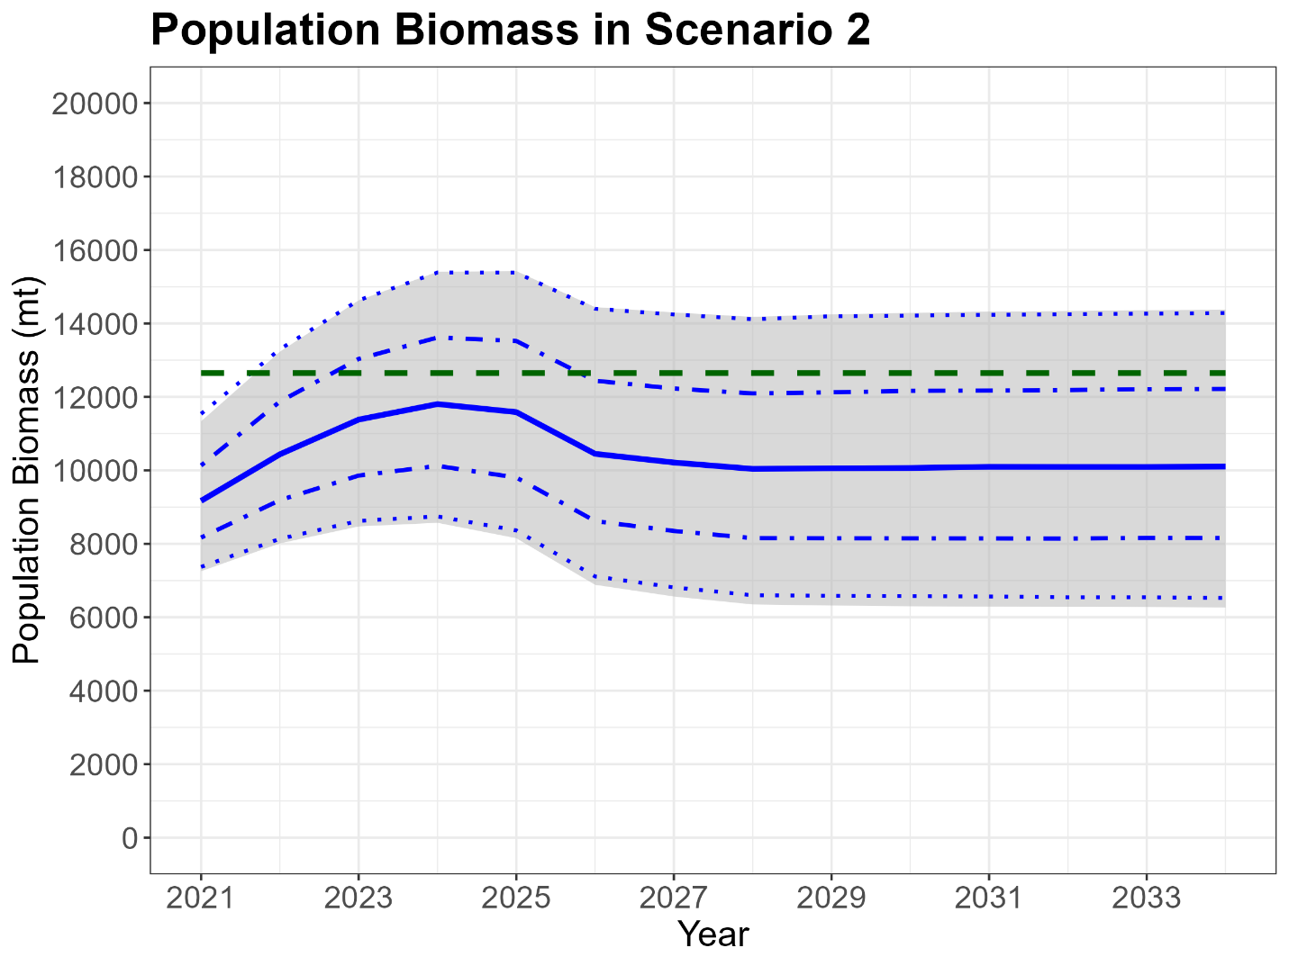

Figure.

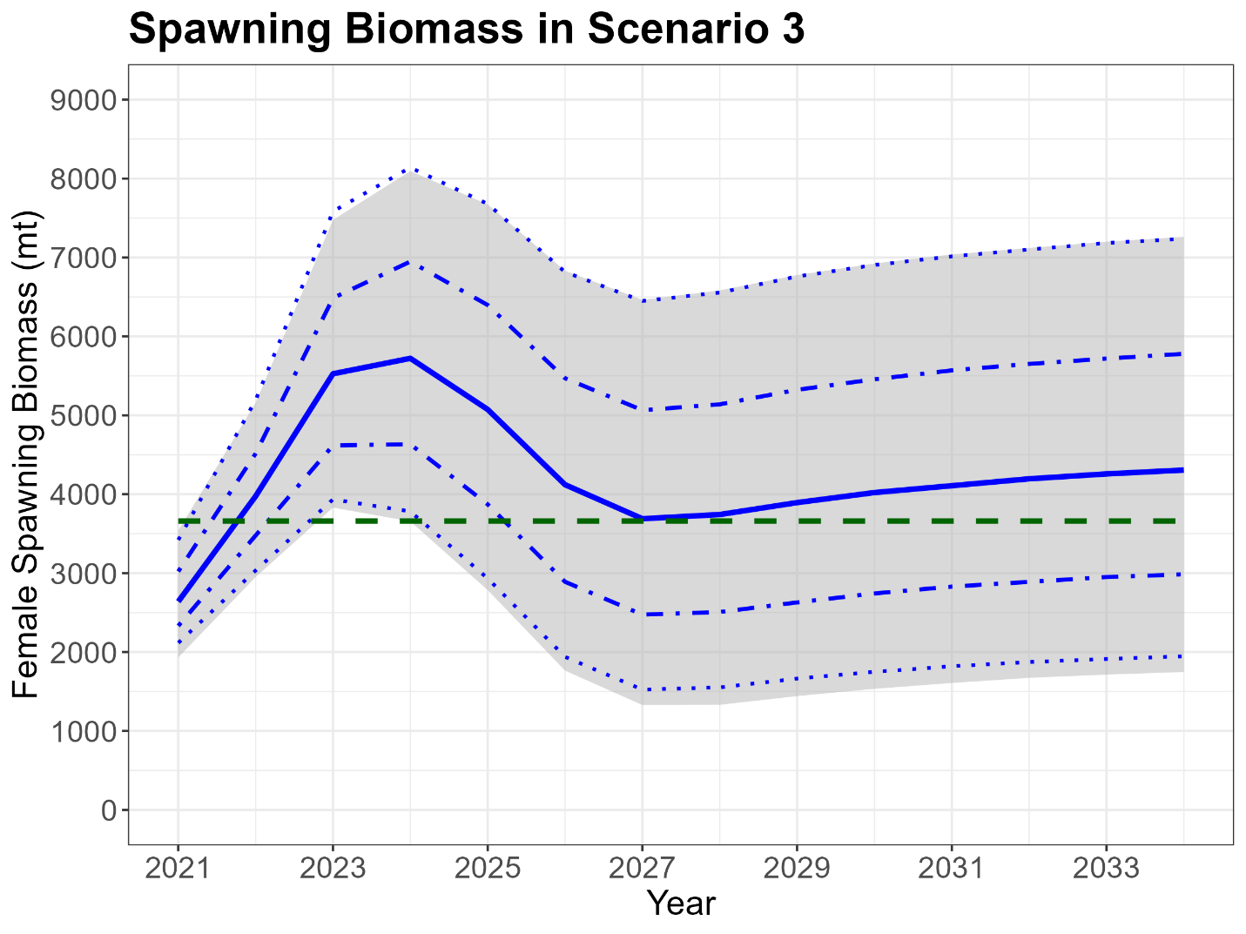

Figure.

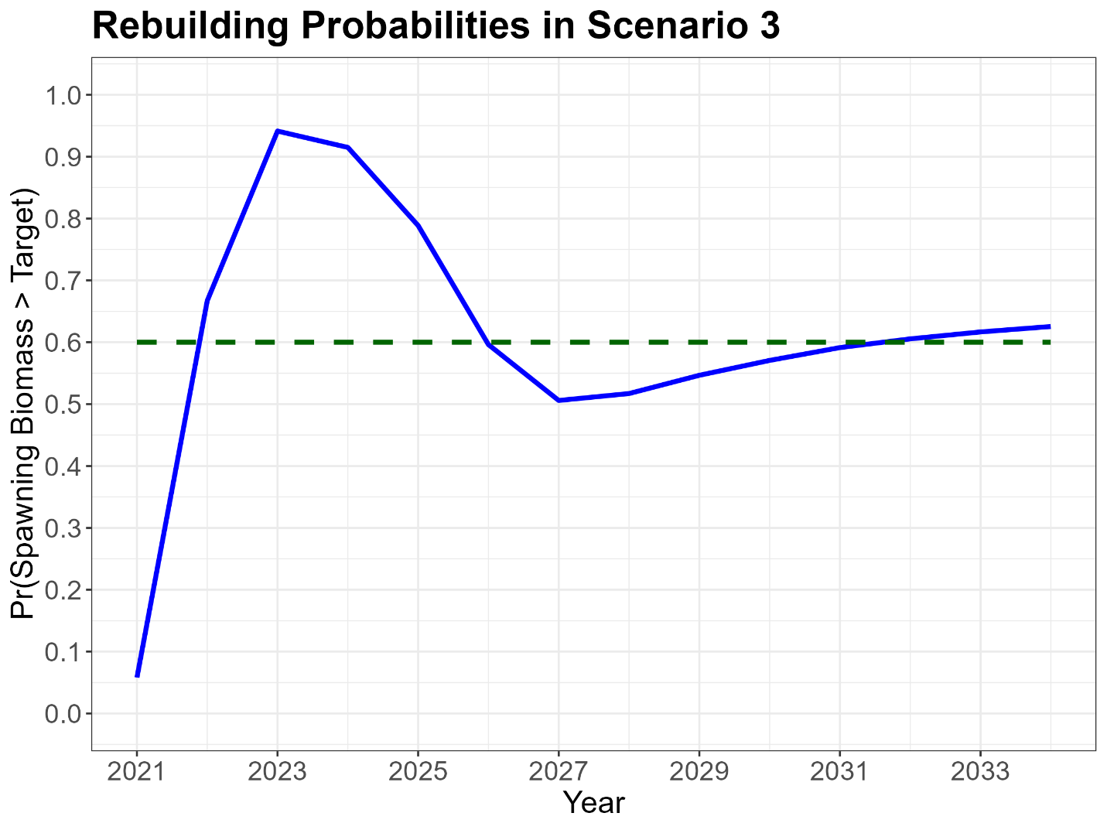

Figure.

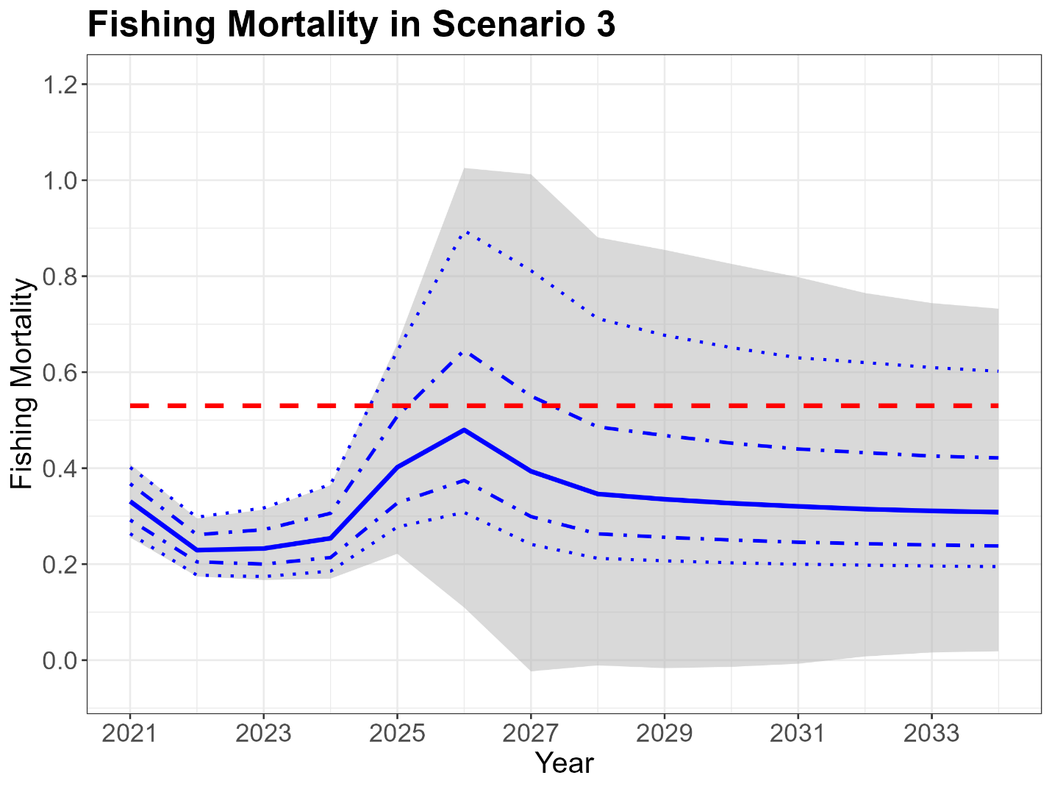

Figure.

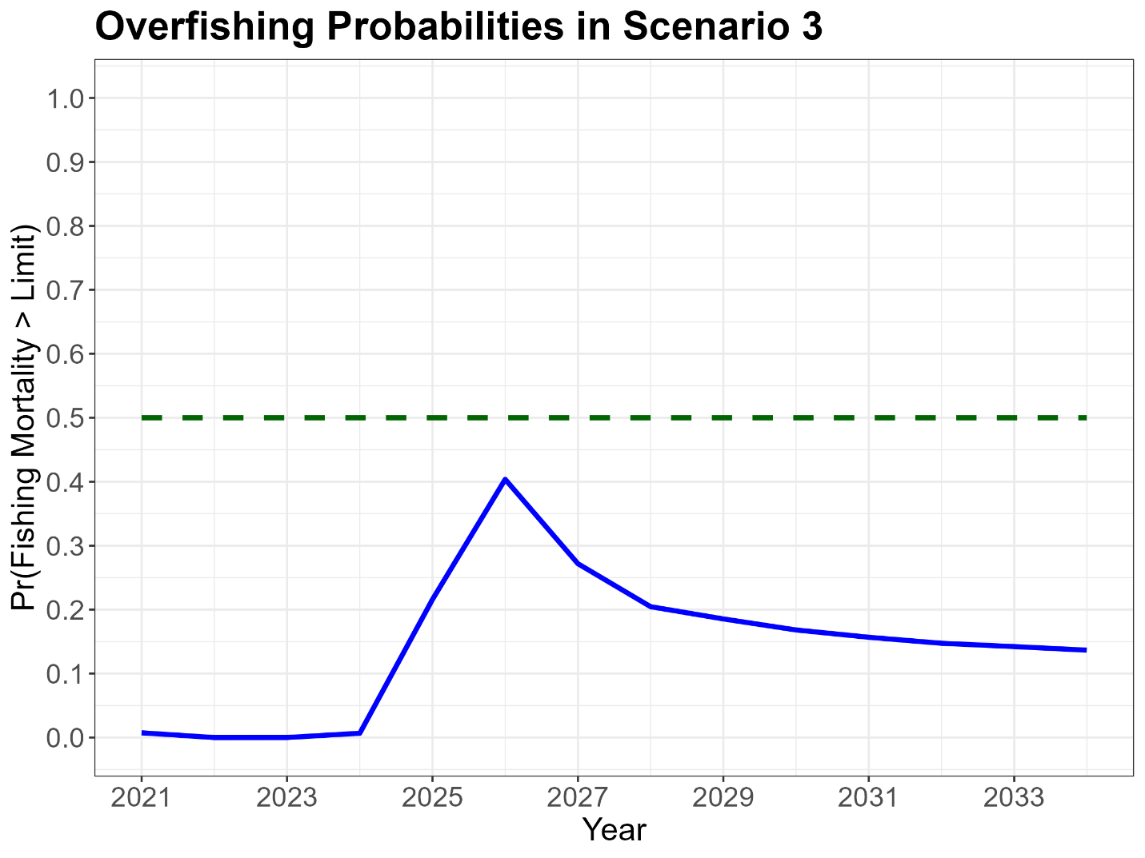

Figure.

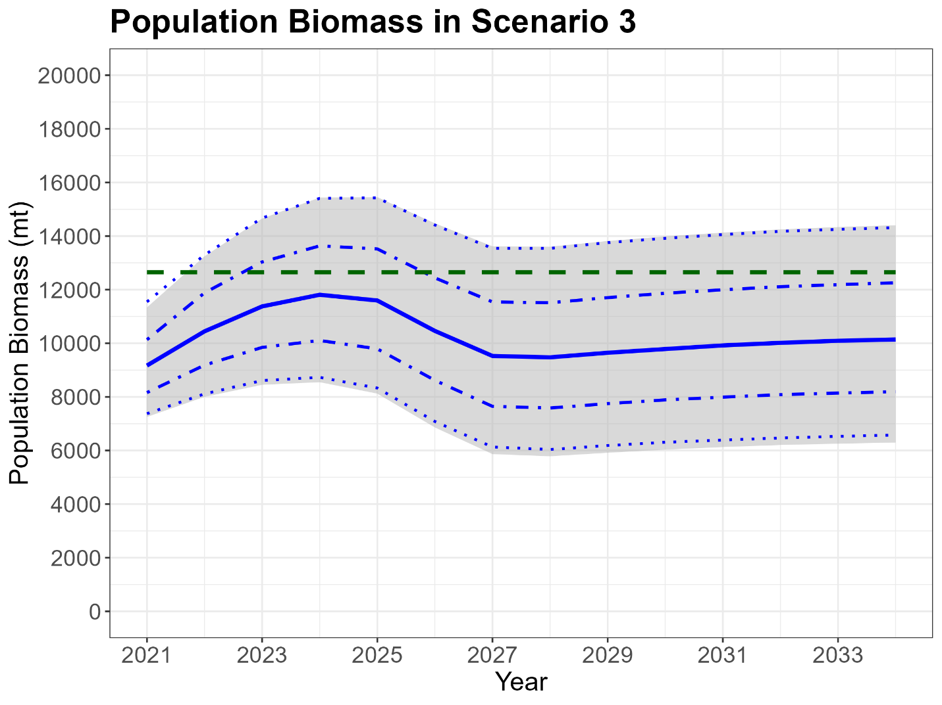

Figure.

